**BH RPA**

**Report CSB for S&OP_BOT project**

**CONTENTS**

1. Version and Approval……………………………………………………………………………………………………………………….2

* 1. Document Approval……………………………………………………………………………………………….……………2
  2. Project Details………………………………………………………………………………………………………………………….4

2. Overview……………………………………………………………………………………………………………........................................3

2.1 Document Resources…………………………………………………………………………………………………............4

2.2 System Infrastructure…………………………………………………………………………………………………………….4

3. Project Overview……………………………………………………………………………………………………...............................5

3.1 Project Overview and Background………………………………………………………………………………..5

3.2 Project Dependencies……………………………………………………………………………………………………………5

4. Business Process Flow………………………………………………………………………………………………………….............6

4.1 Detailed Process Steps………………………………………………………………………………………………………..6

5. Process Exception……………………………………………………………………………………………………………………………….7

1. **Version and Approvals**

|  |  |  |  |
| --- | --- | --- | --- |
| **Version #** | **Date** | **Revised By** | **Reason for change** |
| 1.0 | 10-Feb-2023 | Pavan Kumar | New version |
|  |  |  |  |
|  |  |  |  |
|  |  |  |  |

This document outlines the Business Requirements for process, and accurately reflects the current understanding of actual business requirements. Following approval of this document, requirement changes will be governed by the project’s change management process, including impact analysis, appropriate reviews and approvals.

**1.1 Document Approval**

|  |  |  |  |
| --- | --- | --- | --- |
| **Approver Name** | **Project Role** | **Signature/Approval** | **Date** |
| **Antonino** |  |  |  |
| **Stefano** |  |  |  |
| **Mattia** |  |  |  |
|  |  |  |  |

* 1. Project Details

|  |  |
| --- | --- |
| Project Name | Report CSB for S and OP |
| Project Type | Manufacturing |
| Project Start Date | 11-Aug-2022 |
| Project End Date |  |
| Project Sponsor |  |
| Process Owner | Tonino |
| Project Owner | Stefano |

1. Overview

This document defines the requirements of **Process**. It will be used as the basis for the following activities

* Creating solution designs
* Developing test plans, test scripts, and test cases
* Determining project completion
* Assessing project success
* **2.1 Document Resources**

| **Name** | **Business Unit** | **Role** |
| --- | --- | --- |
|  |  |  |
|  |  |  |
|  |  |  |
|  |  |  |
|  |  |  |

2.2 System Infrastructure

|  |  |
| --- | --- |
| OS Version | Windows10 |
| IE Version | Version 1909 (OS Build 18363.1679) |
| MS Office Version |  |
| System Environment | BH Image |
| Screen Resolution |  |
| Database/SQL Server |  |
| Email Access – IMAP/POP3/Exchange | Outlook |

3. Project Overview

## **3.1 Project Overview and Background**

## **3.2 Project Dependencies**

<List any related known projects that relate in whole or in part or has a dependency on this project.>

## **4 Business Process Flows (As Is)**

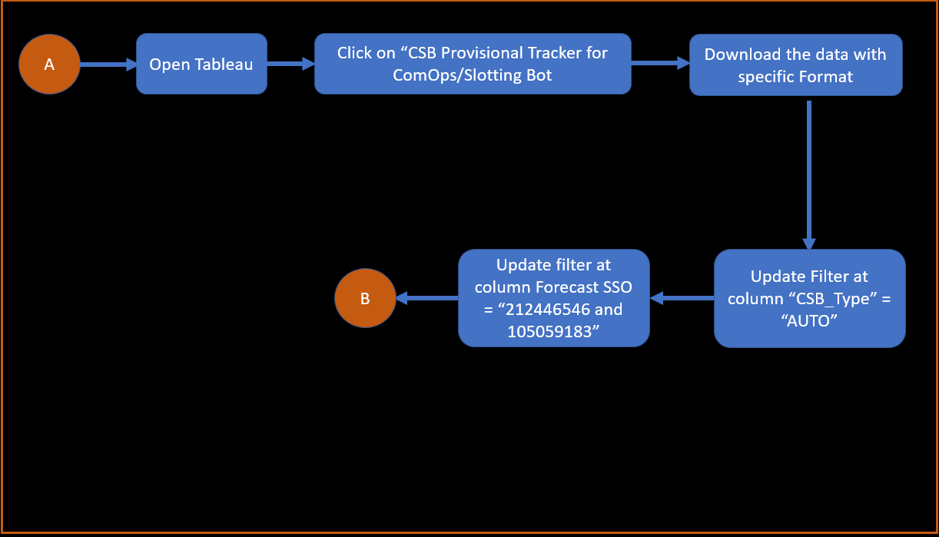 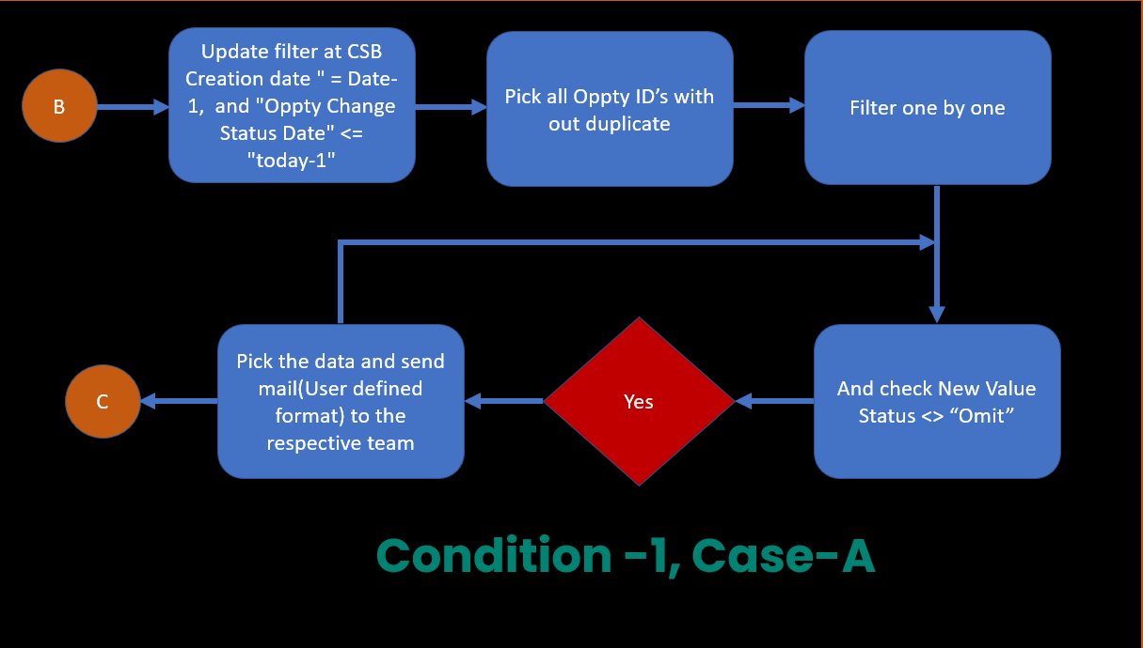

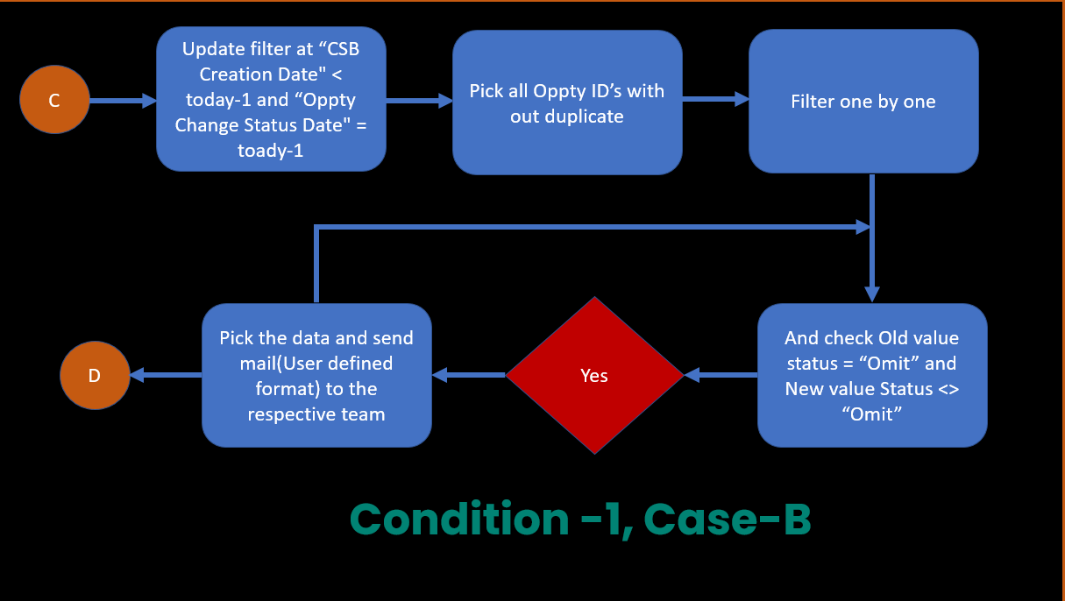 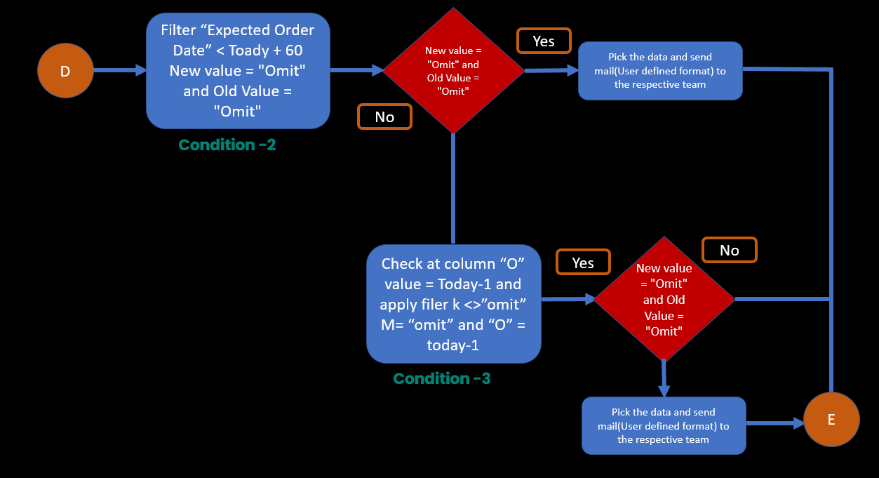

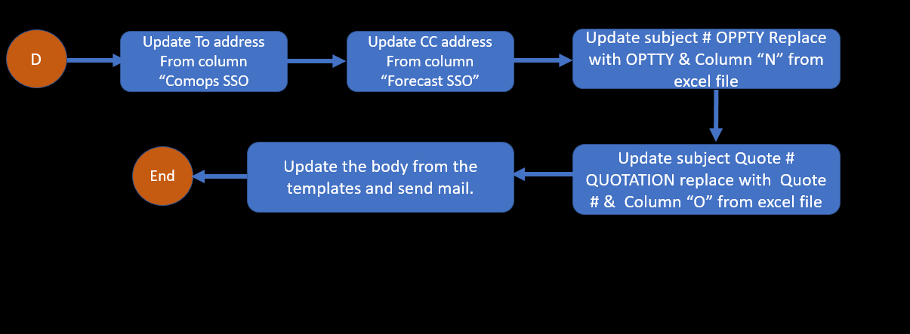

## **4.1 Detail Process Steps**

**Step 1: -**

1. Login to website <https://tableau.bhicrop.com/#/Site/OG_DTS/Views/SOPreportCSBVisibilityonquote/CSBProvisionalTrackerforComOpsSlottingBot?.iid=2>
2. Click on “**CSB Provisional Tracker for ComOps/Slotting BOT**”

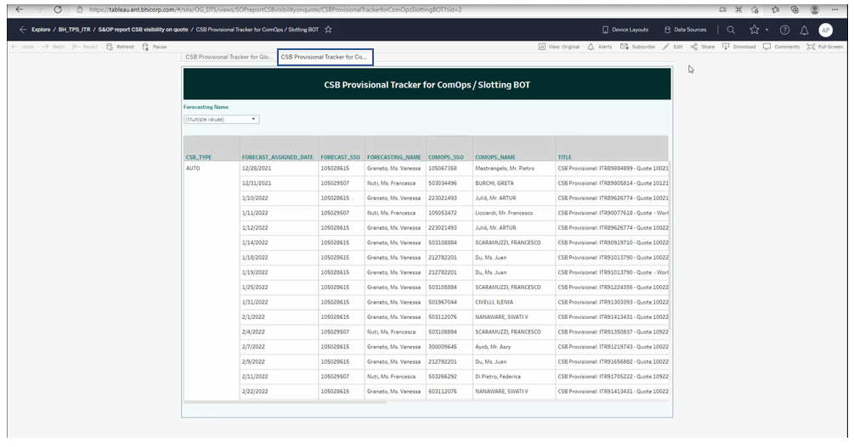

1. Download the data with specific format

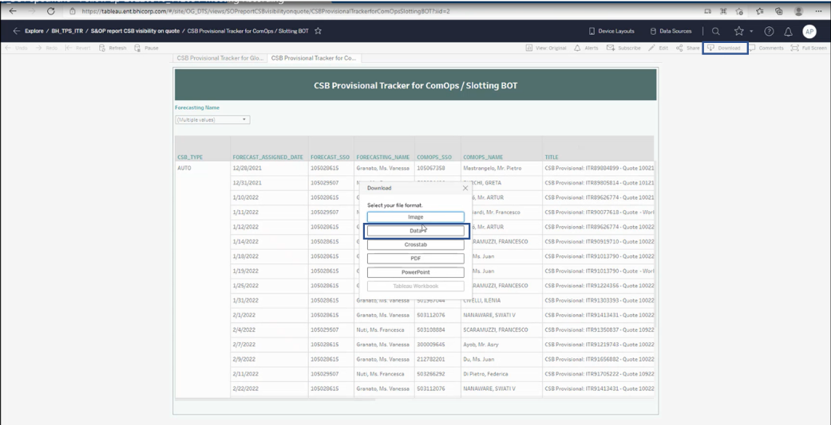

1. We can be able to see the new data pop up as shown in below mentioned snapshot. Select the **full data**, **check the show all column** and click on **Download all rows as a text file** it will save automatically in downloaded folders (if we want to save, we can save if specific folder).

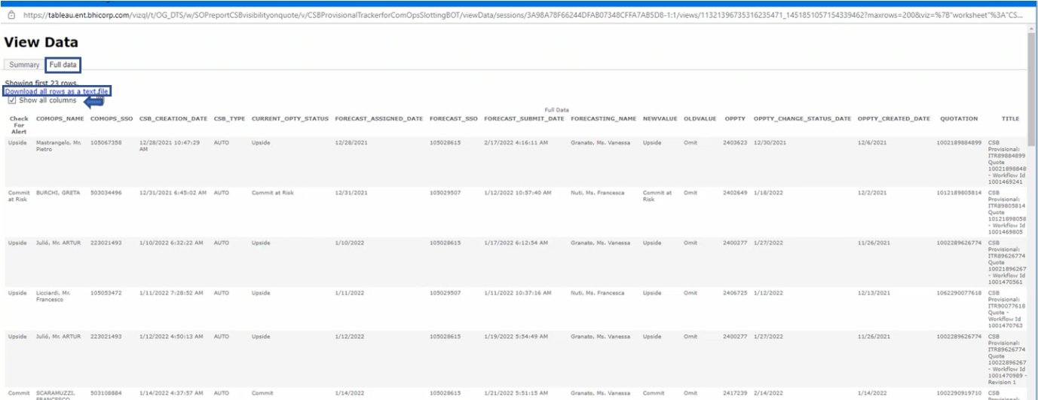

**Step: -2**

**Sending Mail to “Use Email Template_Upside.docx” and “****Use Email Template_Commit & Commit at Risk.docx”**

1. Open Excel File.
2. Go to column “CSB Type” and apply filter “CSB Type” = “AUTO”
3. Go to column “Forecast SSO” and apply filter “CSB Type” = “212446546,105059183”

**Condition:-1 (Case-A)**

1. Update filter at CSB Creation date " = Date-1, and "Oppty Change Status Date" <= "today-1"
2. Pick all Oppty ID’s with out duplicate
3. Filter one by one
4. And check New Value Status <> “Omit”
5. If yes send mail to the client with specific format

**Condition:-1 (Case-B)**

1. Update filter at “CSB Creation Date" < today-1 and “Oppty Change Status Date" = toady-1
2. Pick all Oppty ID’s with out duplicate
3. Filter one by one
4. And check Old value status = “Omit” and New value Status <> “Omit”
5. If yes send mail to the client with specific format

**Condition-2 (Case-A) :Checking condition weather eligible for 60th mail or not**

1. Filter “Expected Order Date” < Toady + 60
2. New value = "Omit" and Old Value = "Omit"
3. send 60th email alert

**Condition-2(Case-A)**

1. Oppty Created Date" = Today -1 and "Expected Order Date" < Today + 60
2. New value = "Omit" and Old Value = "Omit"
3. Then send mail alert to the client

Consider to address From column “Comops SSO” and CC address From “Forecast SSO”

Update subject # OPPTY Replace with OPTTY & Column “N” from excel file

Update the body from the templates and send mail.

Update subject Quote # QUOTATION replace with Quote # & Column “O” from excel file

## **5 Process Exceptions**

<Unknown Scenarios, Errors, Process Exceptions>